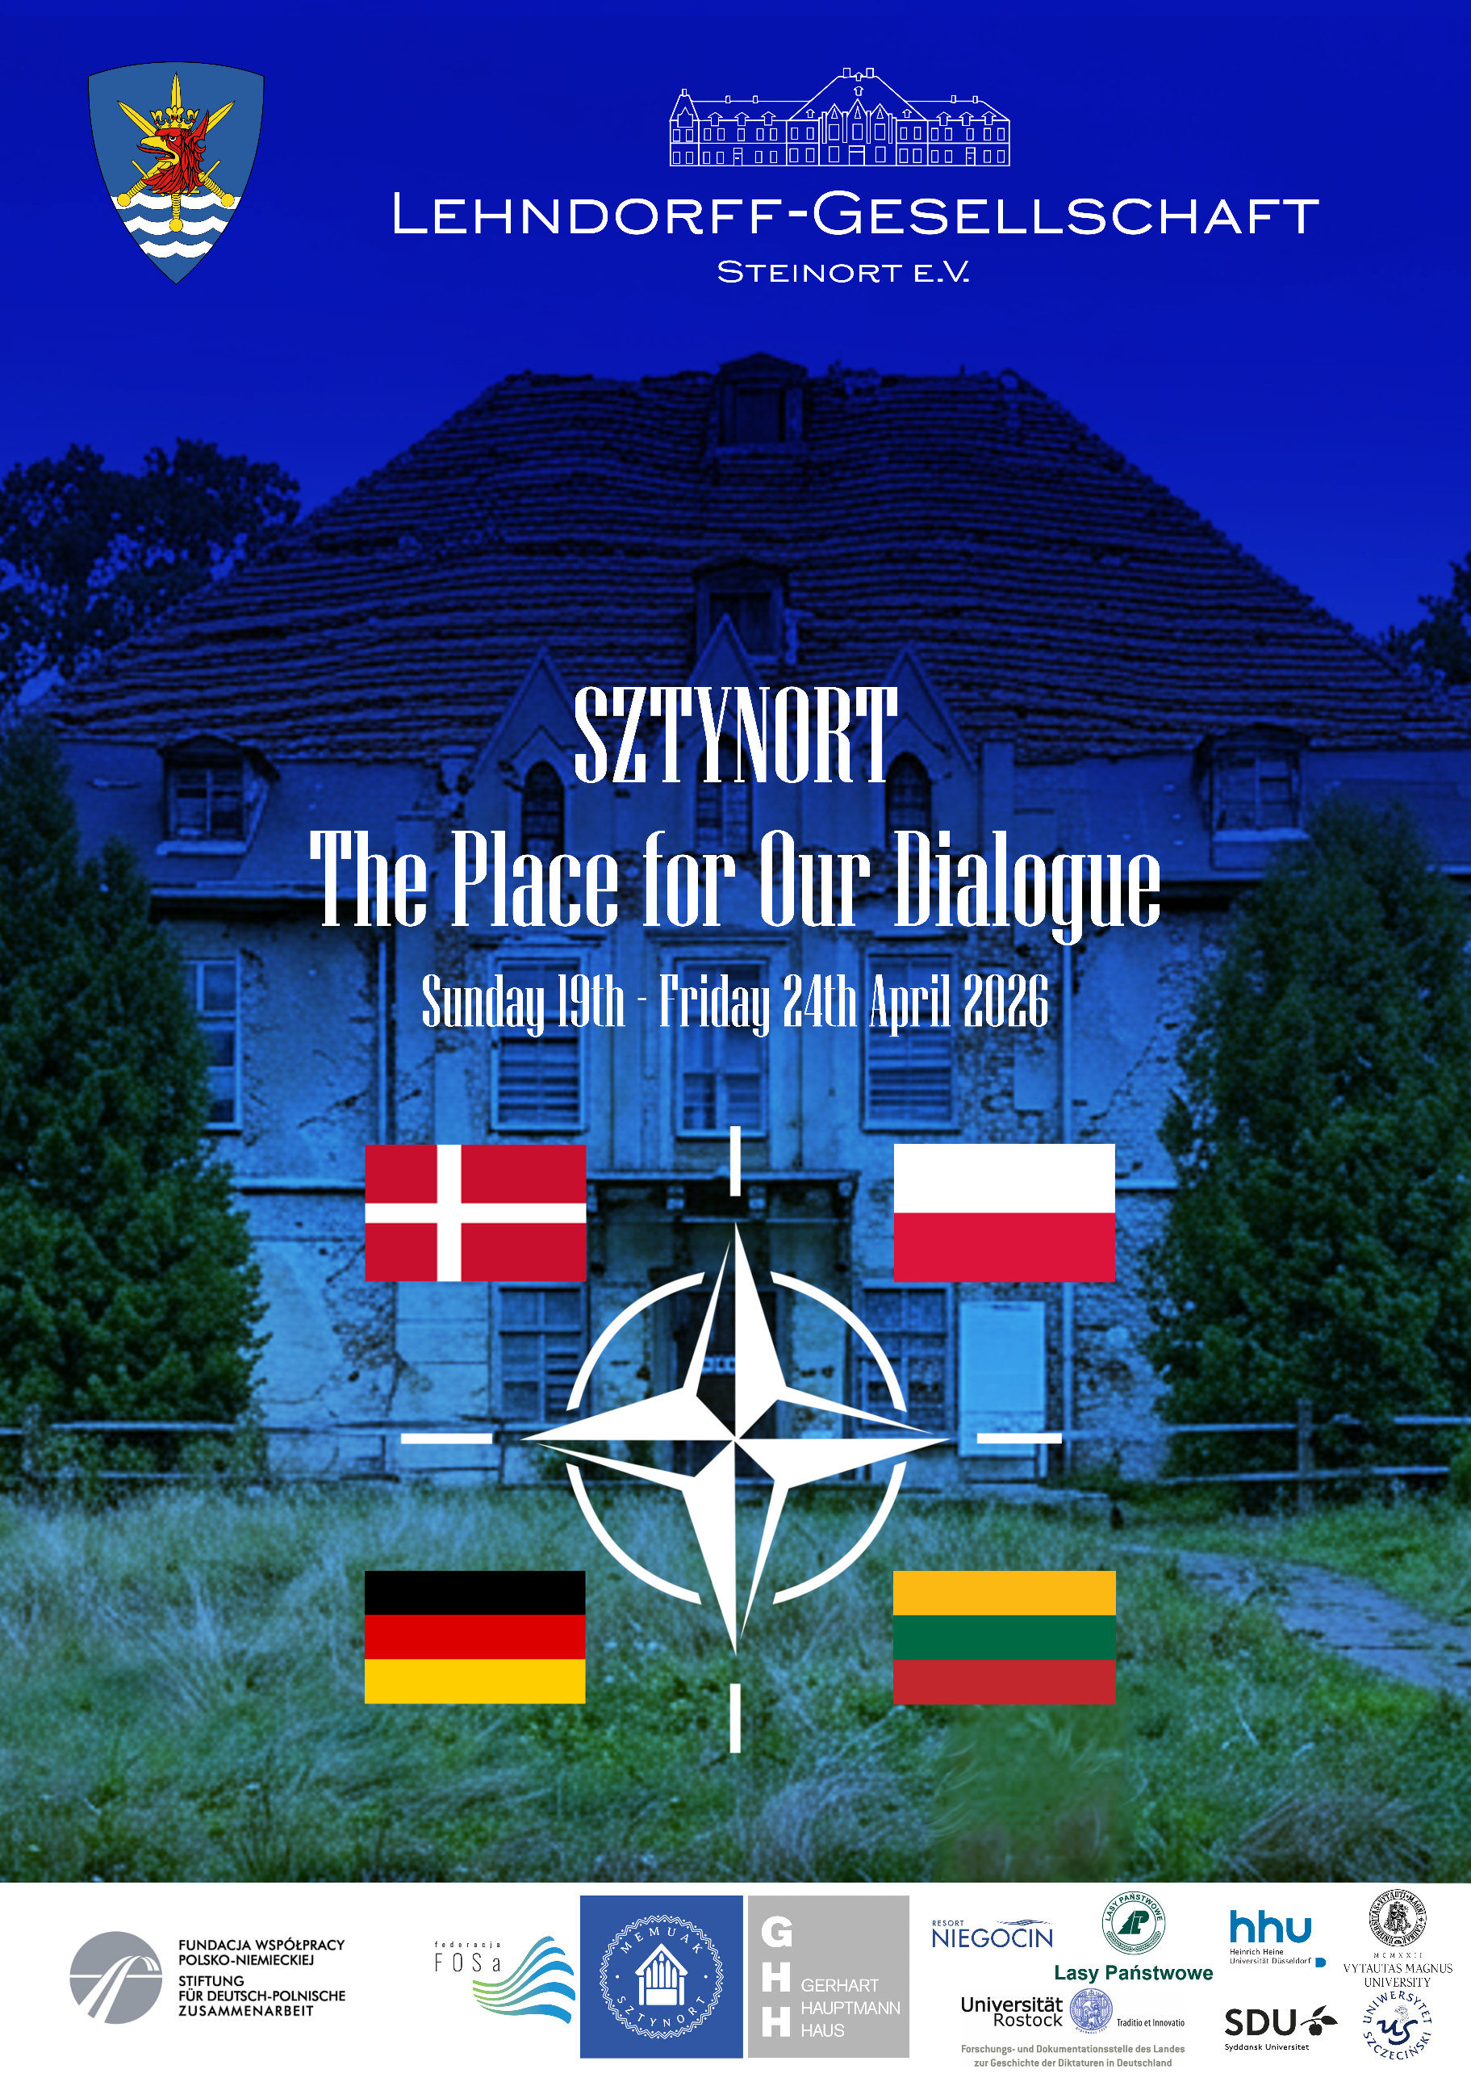

Approximately 24 participants: students and young military personnel from Germany, Poland, Lithuania, and Denmark, supported by academic staff and guest speakers from military and civilian institutions. All of them took part in a multinational NATO-related political-historical seminar focusing on European security, history, and geopolitics.
DAY 1 – Welcome Tour Through the German Embassy
Event started on 19th of April, when the participants visited German Embassy in Warsaw and met the Ambassador.
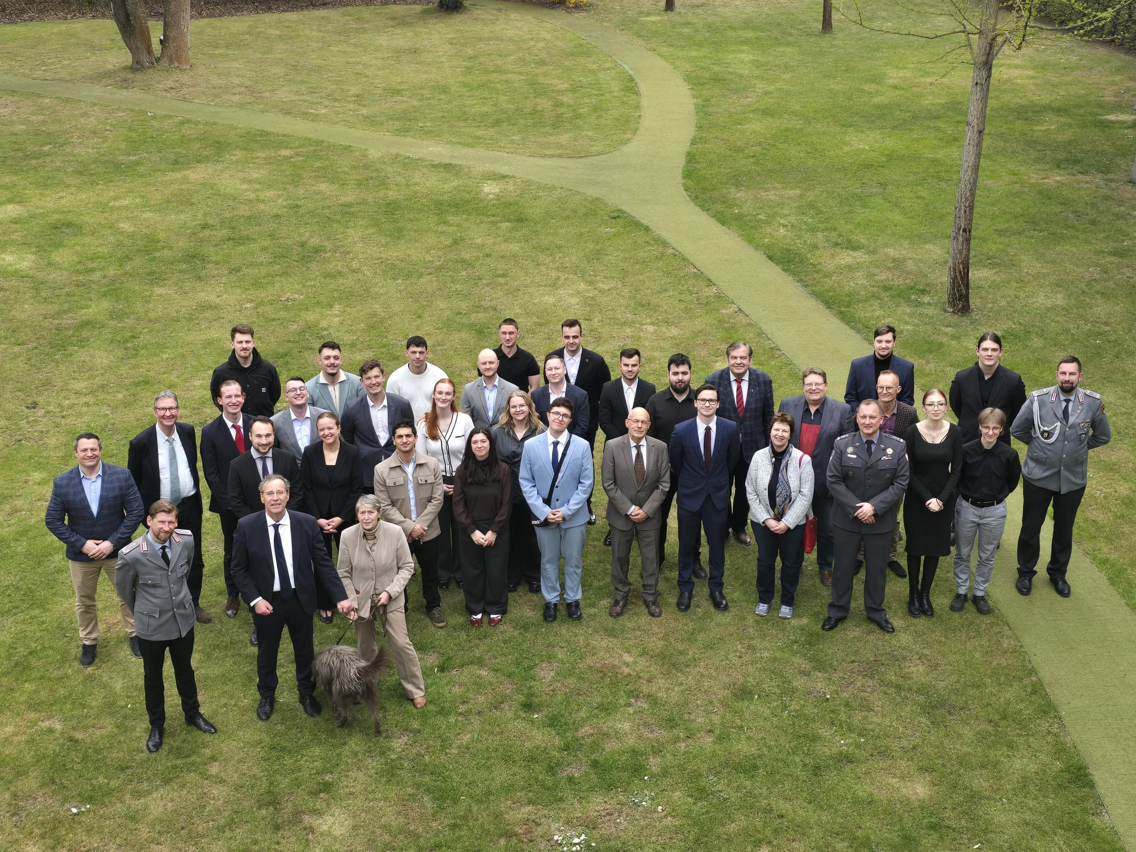

After the visit and lunch at the Embassy, a transfer to the main venue of the seminar, Sztynort/Wilkasy, took place.
Sztynort serves as a historical and symbolic setting for dialogue. In the past, it was closely associated with resistance against the Nazi regime, particularly through the Lehndorff family and their estate at Sztynort, which played a role in the German resistance movement. Today, the location represents a space for reflection, dialogue, and cooperation, with the intention of further developing it as a future center for European dialogue. As an important place in the history of the region, it was chosen as the ideal setting for such an event.
The participants introduced themselves to the rest of the group and stated what they wanted to achieve by taking part in the seminar.
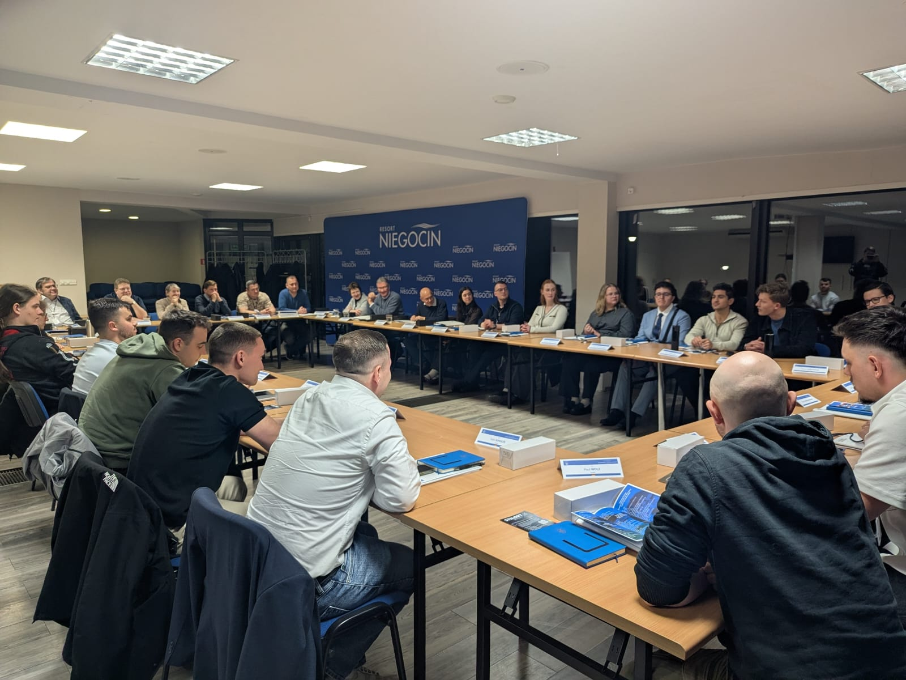
DAY 2 – Borderland Sztynort: Historical and Geopolitical Context
The group visited the Lehndorff Palace in Sztynort. The visit included presentations concerning the history of the palace, its restoration, and the history of the Lehndorff family, particularly Heinrich Lehndorff.
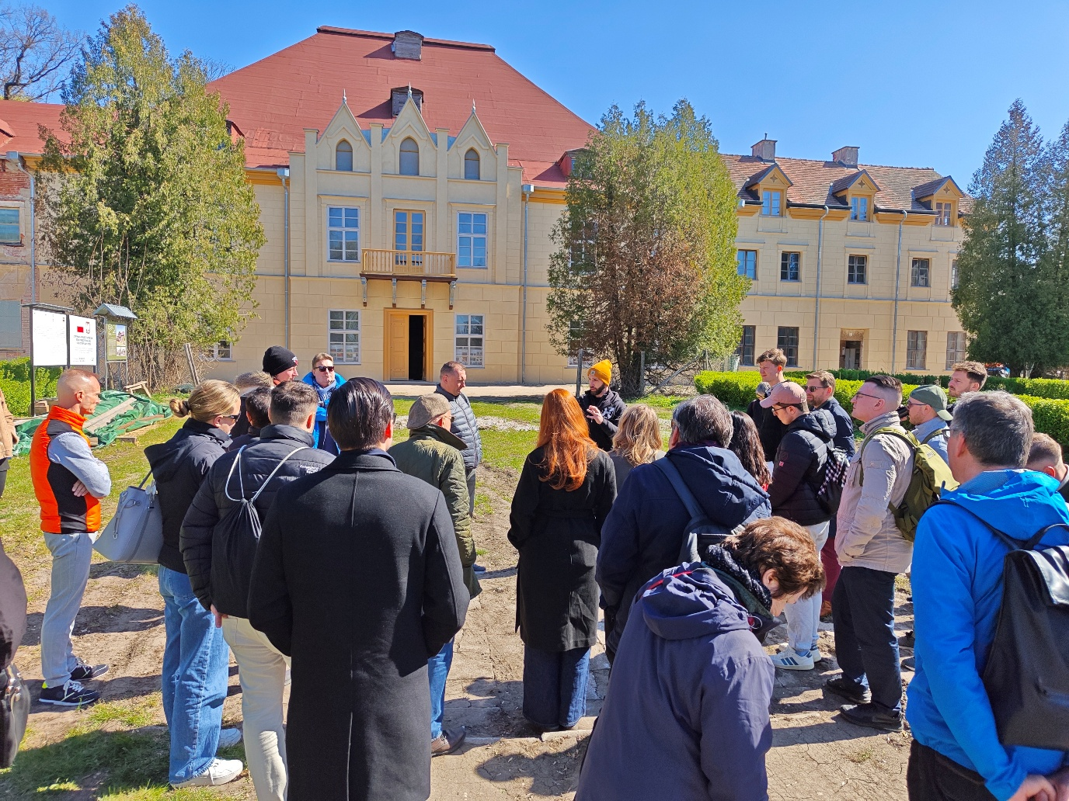
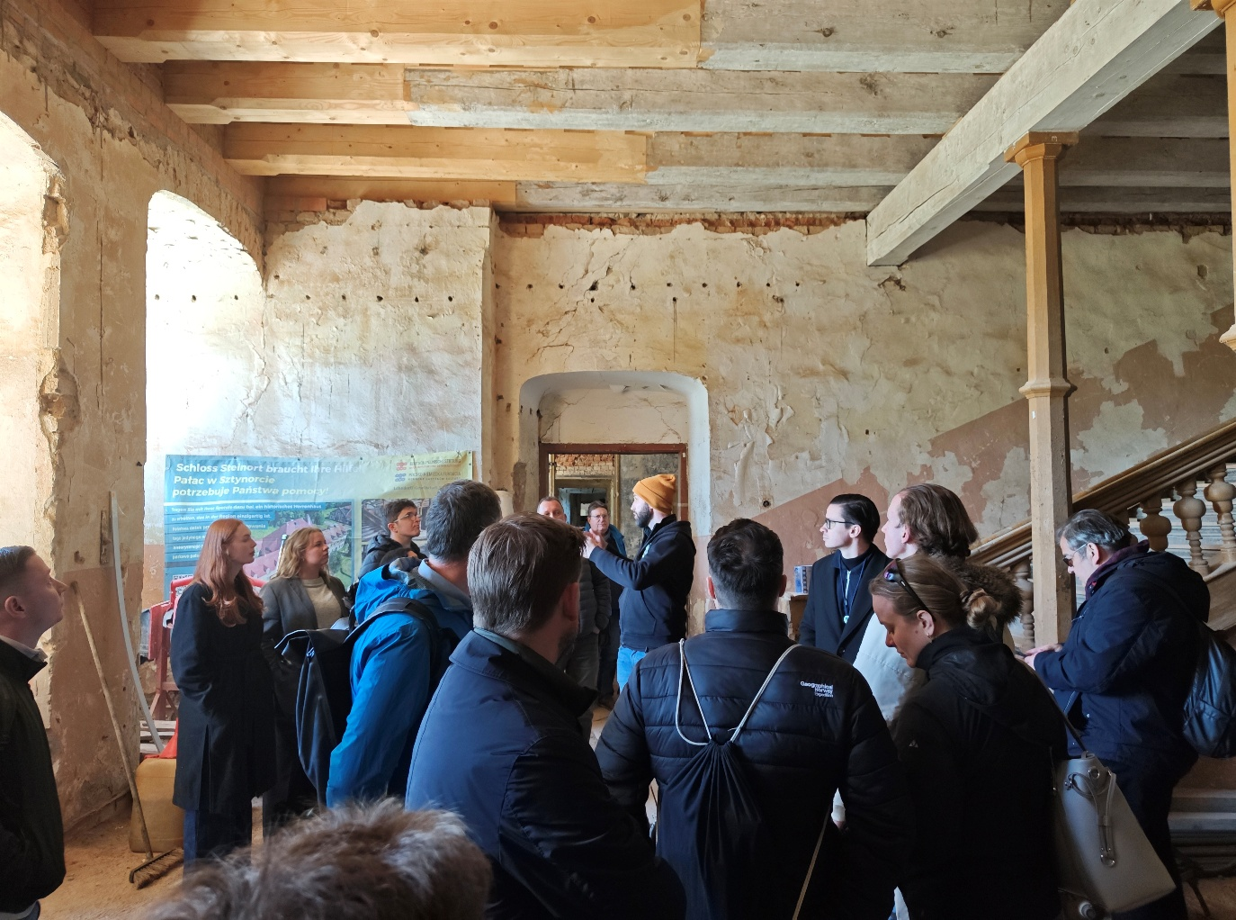
After returning to the resort, participants attended a presentation and discussion
on the topic of “Borders,” conducted by Professor Stefan Creuzberger and Dr. Sabine Grabowski. The lecture focused on Poland during the partitions, the Polish–Lithuanian Commonwealth, and the First World War.
In the evening, a cruise on Lake Niegocin took place.
The atmosphere throughout the conversations remained open and informal. 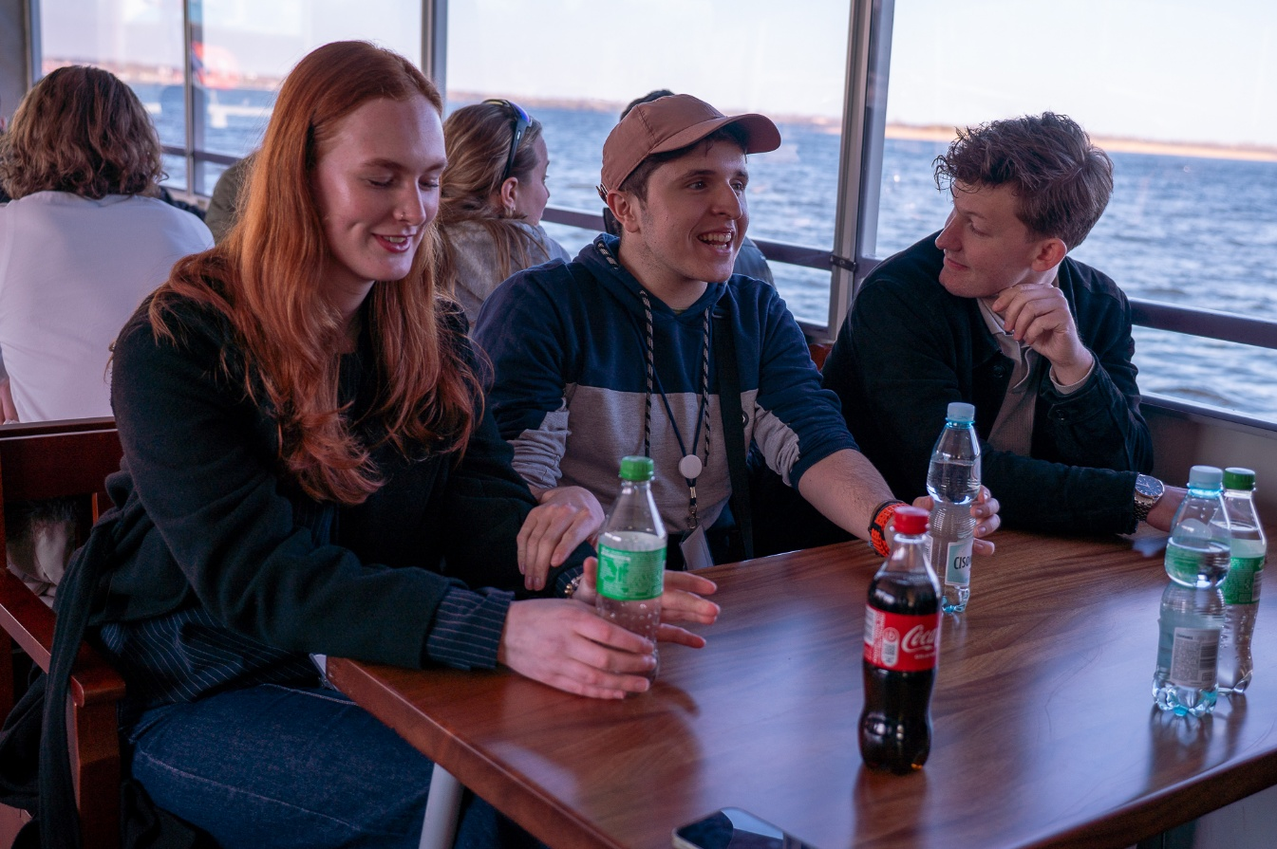

DAY 3 – Focus on History: Borders and Security in North-Eastern Europe
The day began with a meeting with the Mayor of Węgorzewo.
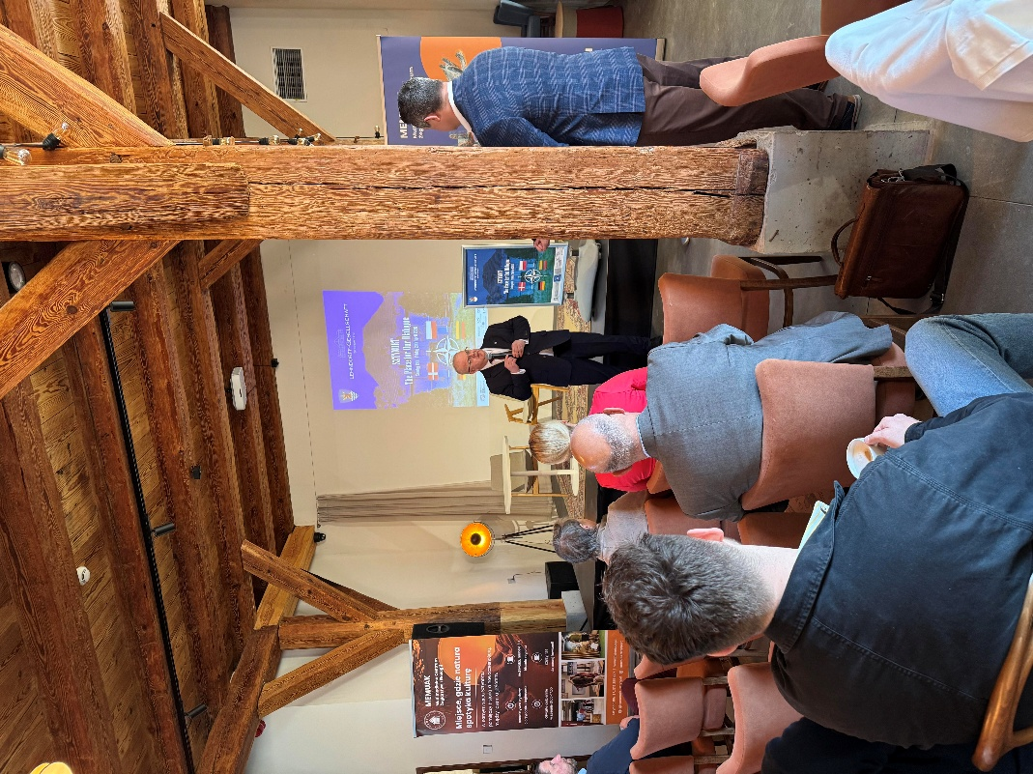
Participants then attended a lecture by Professor Dieter Bingen entitled “A Rare Triumph of Reason in the Heart of Europe: The Amicable Agreement on the German–Polish Border, 1990.” The lecture concerned the Polish–German border before and after the Second World War.
A second lecture, delivered by Professor Andrzej Pukszto and entitled “Lithuanian Ways to Independence: 1918–1990–2004,” focused on Lithuanian history and the country’s path toward independence.
The final lecture of the day concerned the “Polish–German Treaty on Good Neighbourship.”
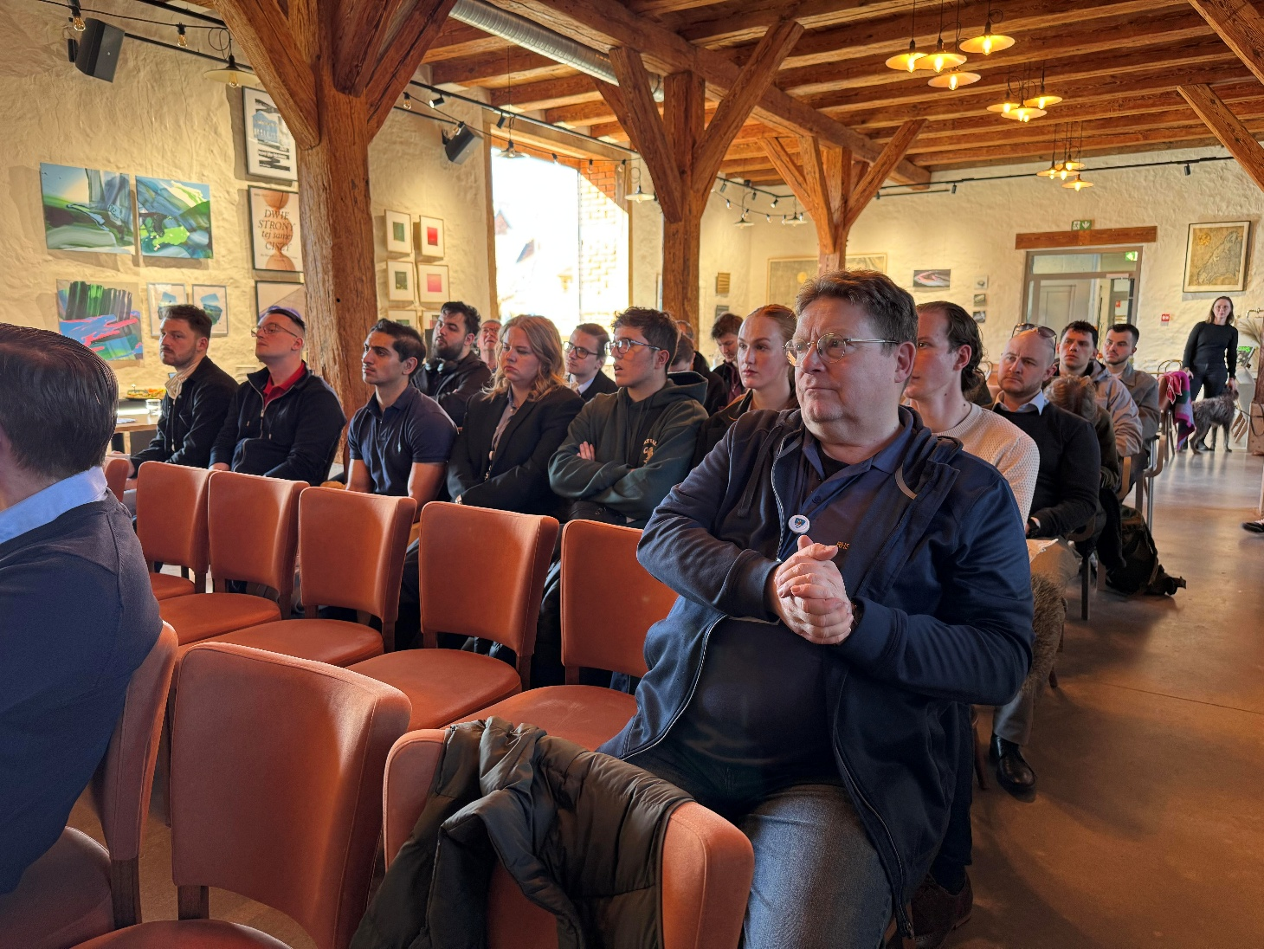
In the afternoon, participants worked in multinational groups on presentations concerning borders, their historical evolution, and the future of NATO cooperation on the Eastern Flank.
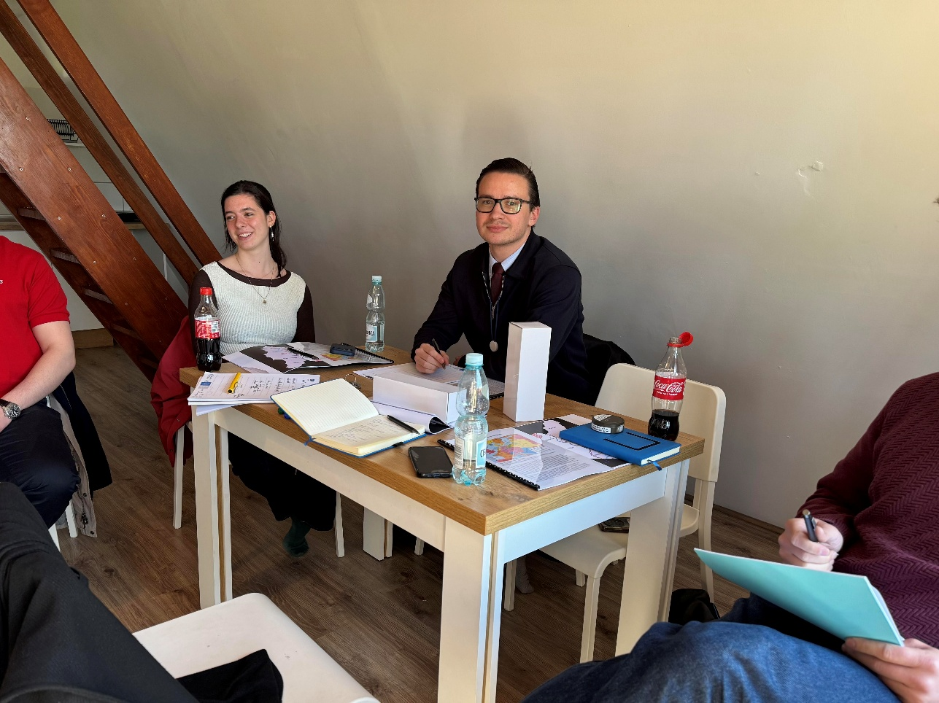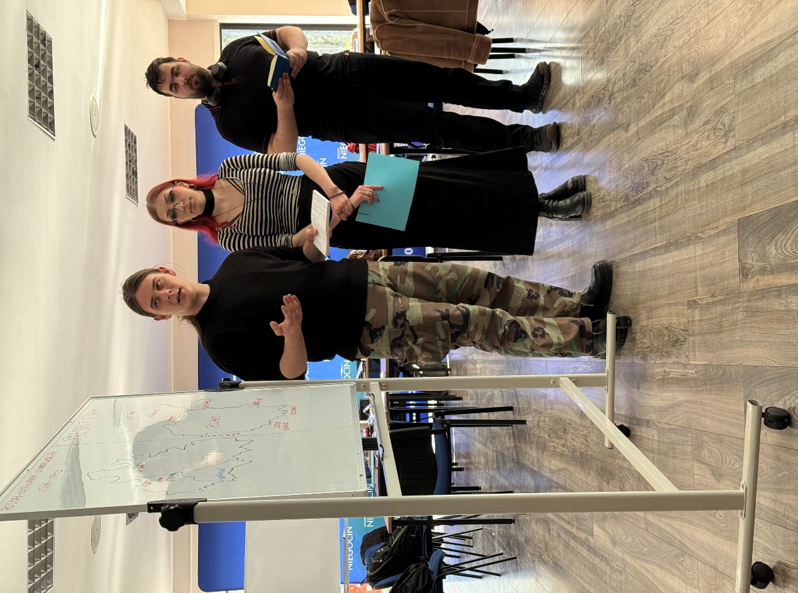

DAY 4 – Excursion to the Wolf’s Lair: A Place Where Borders Shifted
An excursion to the Wolf’s Lair took place following breakfast. Before the beginning of the tour, Colonel von Plüskow presented the historical background of the assassination attempt against Adolf Hitler on 20 July 1944.
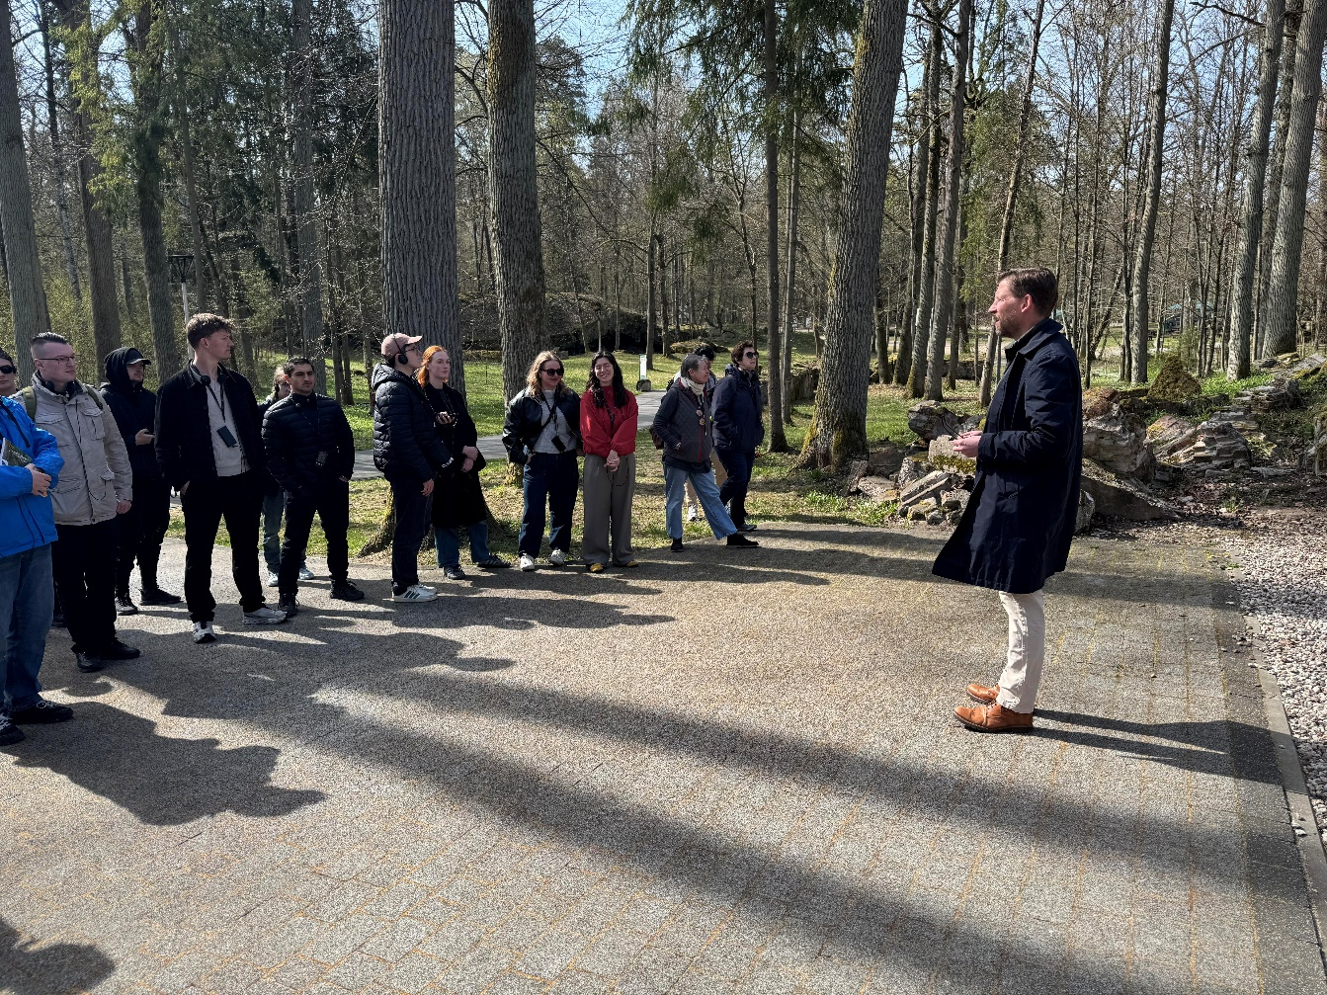
The tour included visits to the bunker complex, exhibitions concerning the Second World War, a reconstruction of the room in which the assassination attempt occurred, and a section devoted to the Warsaw Uprising.

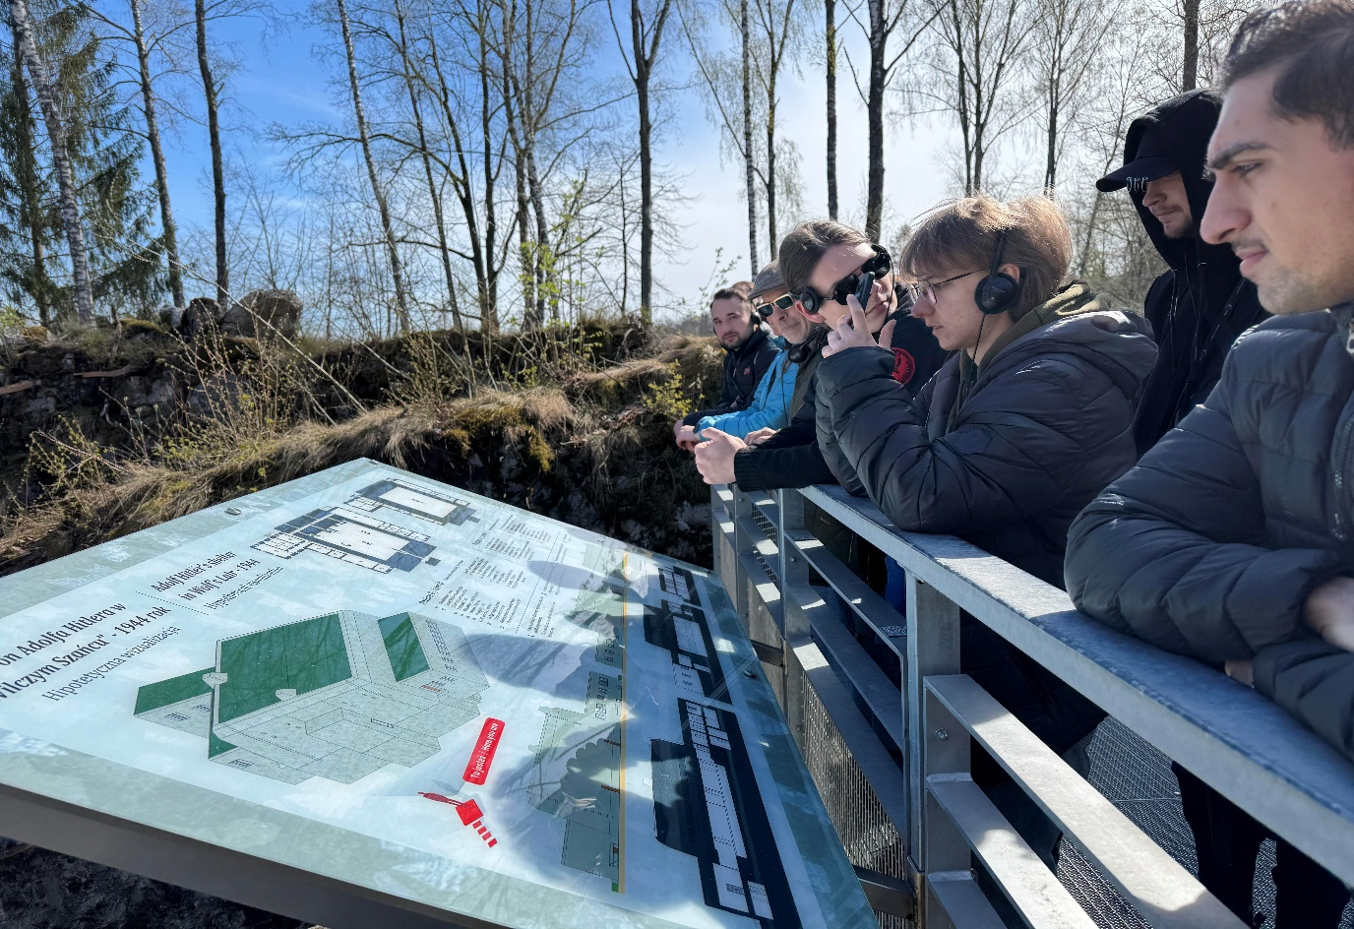
Following lunch, participants attended a lecture by Dr. Heckert entitled “The Network of July 20th, 1944,” concerning the resistance movement in Nazi Germany.
A discussion then took place regarding resistance against dictatorship and the moral responsibilities of citizens under authoritarian rule.
Later, soldiers from participating countries presented their military oaths and discussed their historical development and significance. Additional discussion concerned civic responsibility, resistance movements, and the role of scouting organizations during the Second World War.
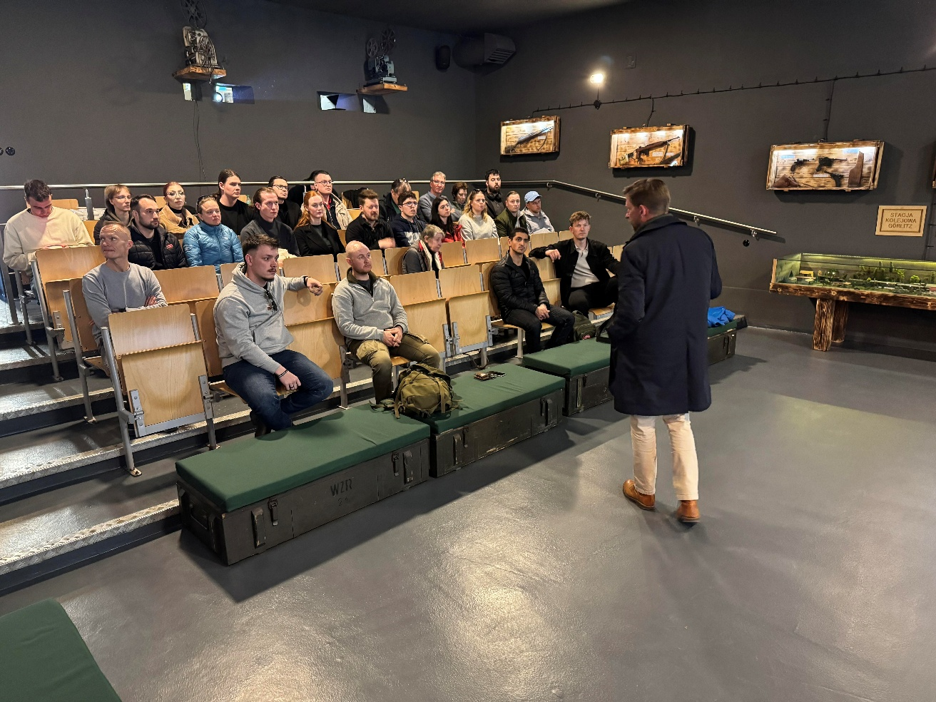

DAY 5 – All Quiet on the Eastern Borders? Challenges for NATO and Europe
The day began with a meeting with Major General MNC NE Brian Nissen. A presentation was subsequently delivered by Colonel von Plüskow regarding NATO’s structure, activities, and current responsibilities. 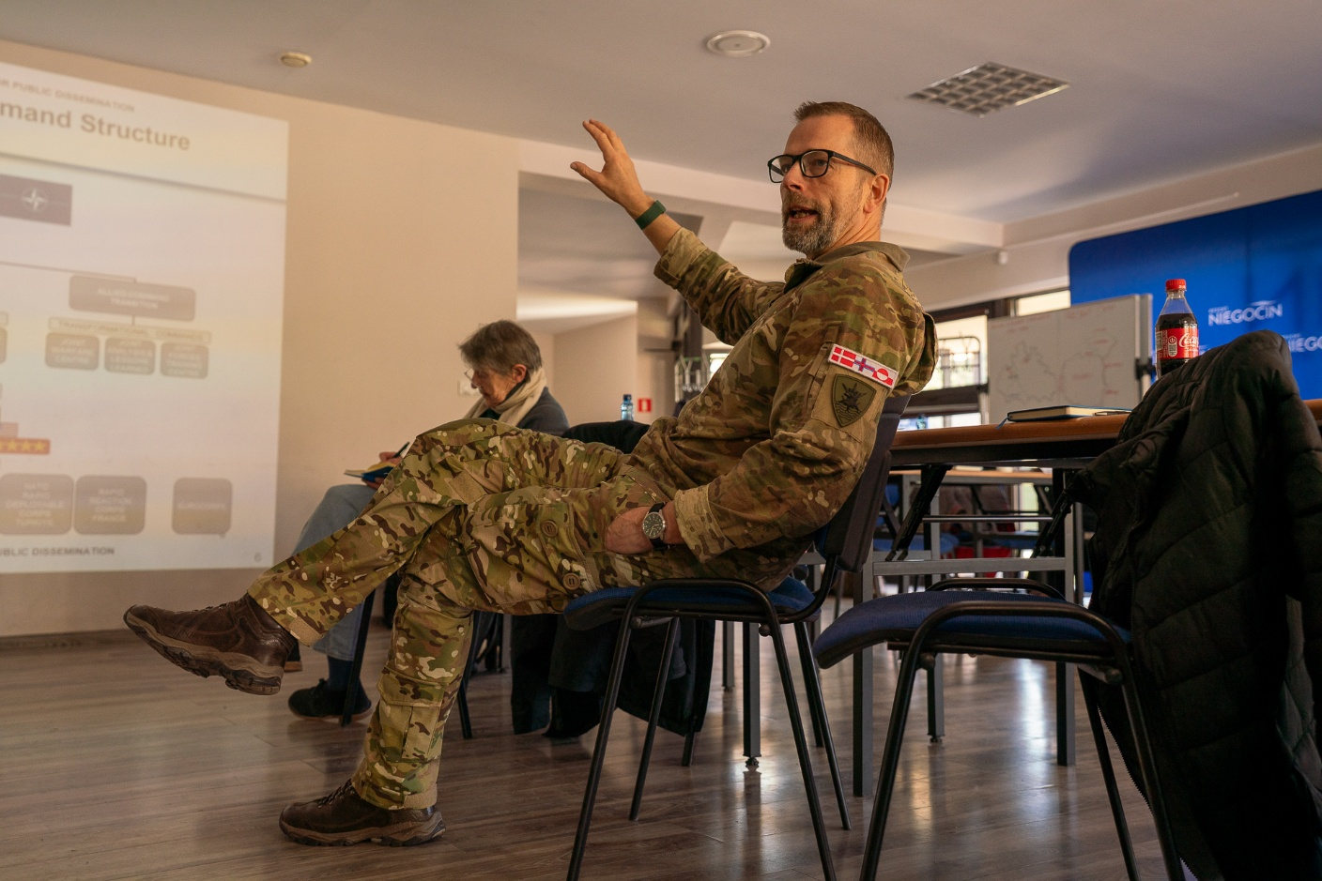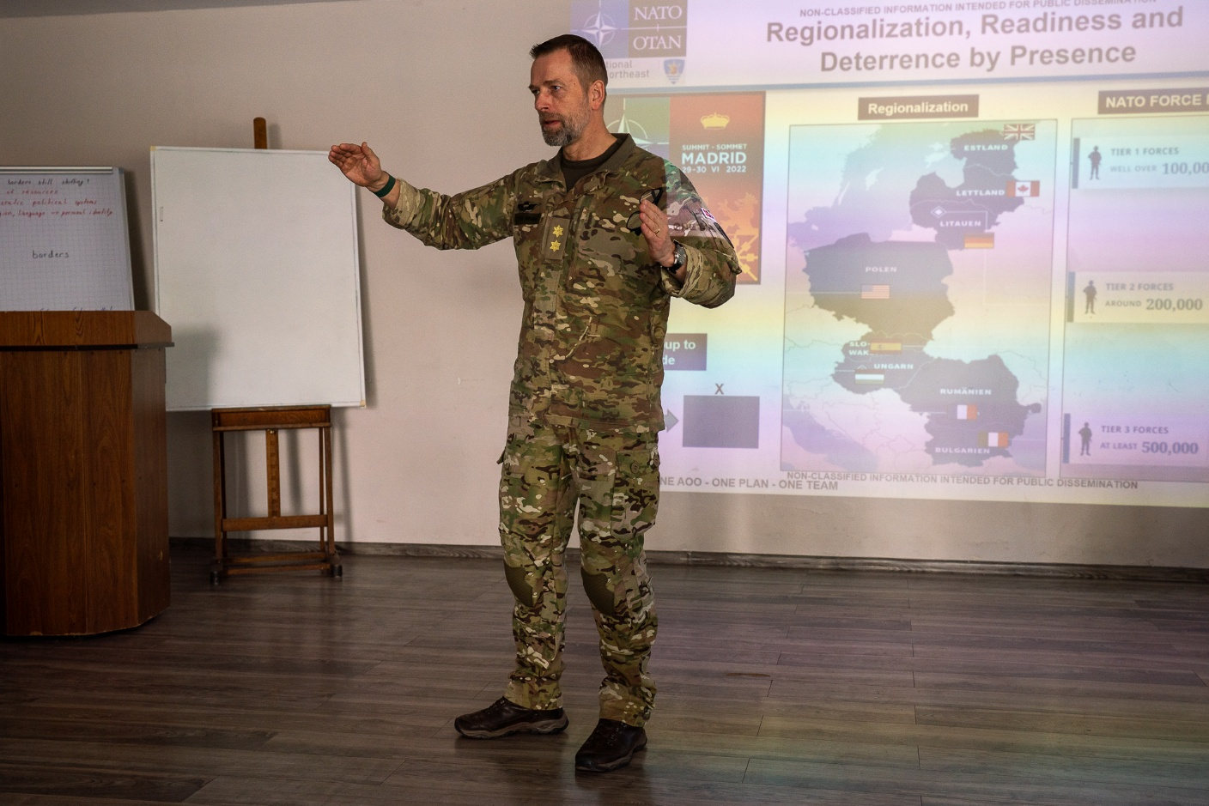

Participants also took part in a short online meeting with the President of the FOSA Foundation, followed by a question-and-answer session concerning NATO, the Eastern Flank, and regional security.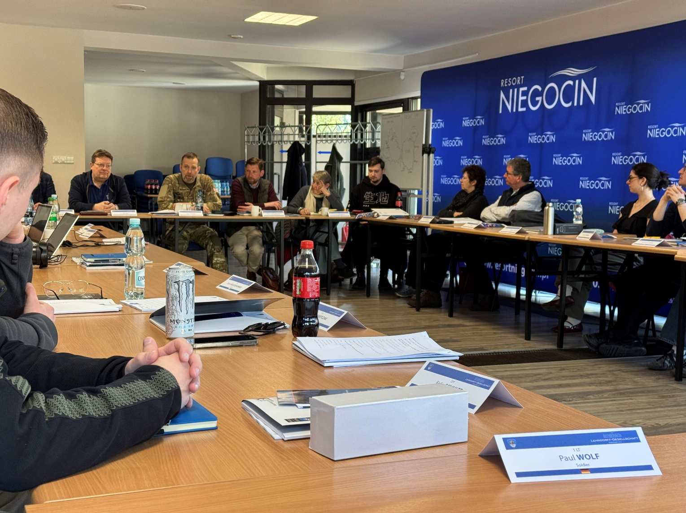
The Lithuanian delegation departed later that day and received formal thanks for its participation and contributions to the seminar discussions. 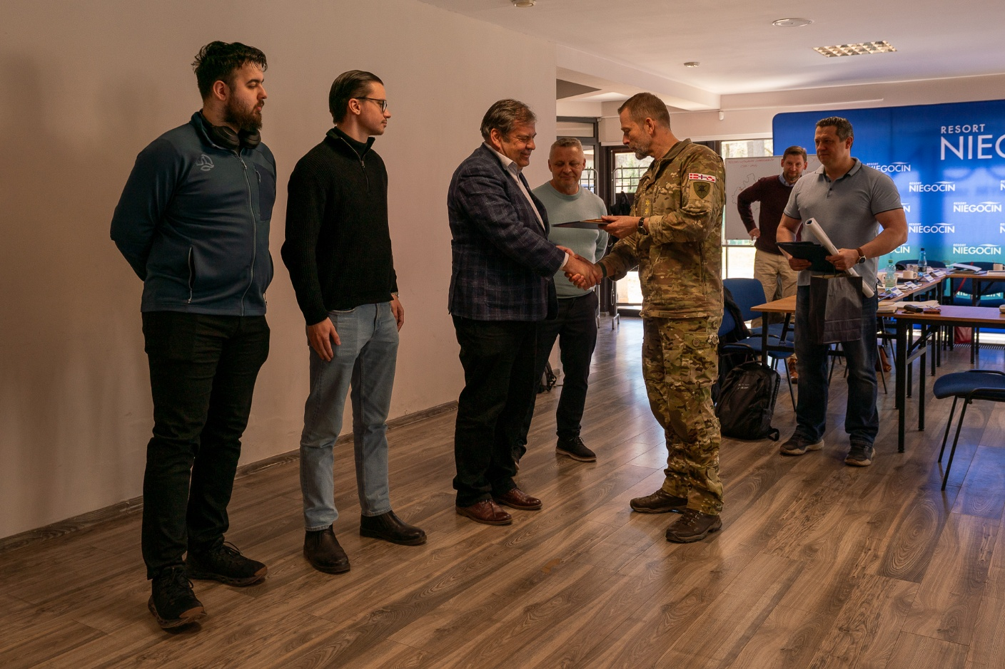

Following the departure of senior guests, participants gathered to evaluate whether the seminar had fulfilled its objectives.
In the evening, a farewell barbecue was organized, providing an opportunity for further integration among students and soldiers from participating countries.
DAY 6 – Farewells
After breakfast and departure preparations, farewells were exchanged before everyone returned home.
